Problem 1

[ 1 0 2 1 ] a ○ ○ b

[ 0 1 1 2 ]

[ 2 1 1 0 ]

[ 1 2 0 0 ] c ○ ○ d

Problem 2

1) a) A = [ 0 0 0 1 1 ] B = [ 1 1 0 0 0 0 ] D = [ 2 0 0 0 0 ]

[ 0 0 0 1 1 ] [ 0 0 1 1 0 0 ] [ 0 2 0 0 0 ]

[ 0 0 0 1 1 ] [ 0 0 0 0 1 1 ] [ 0 0 2 0 0 ]

[ 1 1 1 0 0 ] [ 1 0 1 0 1 0 ] [ 0 0 0 3 0 ]

[ 1 1 1 0 0 ] [ 0 1 0 1 0 1 ] [ 0 0 0 0 3 ]

b) A = [ 0 1 1 0 0 ] B = [ 1 0 1 0 ] D = [ 2 0 0 0 0 ]

[ 1 0 1 0 0 ] [ 1 1 0 0 ] [ 0 2 0 0 0 ]

[ 1 1 0 0 0 ] [ 0 1 1 0 ] [ 0 0 2 0 0 ]

[ 0 0 0 0 1 ] [ 0 0 0 1 ] [ 0 0 0 1 0 ]

[ 0 0 0 1 0 ] [ 0 0 0 1 ] [ 0 0 0 0 1 ]

2) D为对角矩阵, 其中对角线上第i行i列的元素D(i, i)为顶点i的度数

C = BB^T对角线元素C(i, i)为顶点i度数, 其他元素C(i, j)为i, j邻接关系

D = C – A将所有C(i, j) (i≠j)转化为0, 剩余对角线元素C(i, i)为顶点i度数

Problem 3

存在双射f: V1→V2, g: E1→E2

a | b d e A | C F G f(a) = F g(ab) = AF g(ae) = FH

b | a c f B | D E H f(b) = A g(bc) = AG g(bf) = AC

c | b d g C | A E H f(c) = G g(cd) = DG g(cg) = EG

d | a c h D | B F G f(d) = D g(ad) = DF g(dh) = BD

e | a f h E | B C G f(e) = H g(ef) = CH

f | b e g F | A D H f(f) = C g(fg) = CE

g | c f h G | A D E f(g) = E g(gh) = BE

h | d e g H | B C F f(h) = B g(eh) = BH

∀e∈E1, φ(e)={u, v}当且仅当g(e)∈E2, φ(g(e))={f(u), f(v)}, [左图]和[右图的补图]同构

Problem 4

具有4个顶点的非同构简单图共有11个, 如图

1) 包含C3的有(5), (8), (9), (10), (11), 共5个

2) 无孤立点的有(3), (6), (7), (8), (9), (10), (11), 共7个

3) 无向图是二部图的充要条件是至少有两个顶点, 且所有回路的长度均为偶数

则(1), (2), (3), (4), (6), (7), (8)都是二部图, 共7个

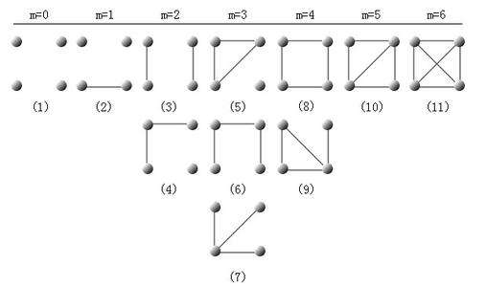

Problem 5

设G的顶点数为n, 简单图G和G¯的和是n阶完全图, 又G和G¯同构,

则n阶完全图的边数n(n-1)/2是G的边数的两倍, n(n-1)是4的倍数

又G是正则图, G的边数是n的倍数, 设边数为kn(k∈N),

有2kn=n(n-1)/2, n-1=4k, (n-1)≡0(mod 4), 即n≡1(mod 4)

Problem 6

1)

2)